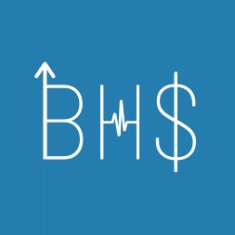
Business Healthcare Society
University of Ottawa, 75 Laurier Ave. E, Ottawa, ON K1N 6N5

Invoice Number:  002  Invoice Date: November 13th 2024 | Bill To:  Telfer BIPOC Business Society 1218 111 Cooper St  Ottawa, ON K2P 2E3
Instructions:
Please make the cheque payable to: The Business Healthcare Society E-Transfer email:
bhs.financeteam@gmail.com

Address:
Room 2105 L, Floor 2
55 Laurier Avenue East,
Ottawa, ON
K1N 6N5

Description:  BHS x BBS Case Crack Competition | $376.21

